System design is the process of defining the architecture, components, modules, interfaces, and data for a system to satisfy specific requirements. Think of it as the blueprint for a complex piece of machinery; before you start building (coding), you need to understand how all the parts will interact, scale, and handle failure.
In modern computer science, system design often focuses on distributed systems—systems that run on multiple networked computers to handle massive amounts of data and users.

Core Components of System Design
To build a robust system, engineers focus on several foundational pillars:
1. Scalability
This is the system's ability to handle an increasing amount of work.
- Vertical Scaling (Scaling Up): Adding more power (CPU, RAM) to an existing machine.
- Horizontal Scaling (Scaling Out): Adding more machines to the network to share the load.
2. Load Balancing
When you have multiple servers, you need a "traffic cop" to distribute incoming requests so no single server becomes overwhelmed.
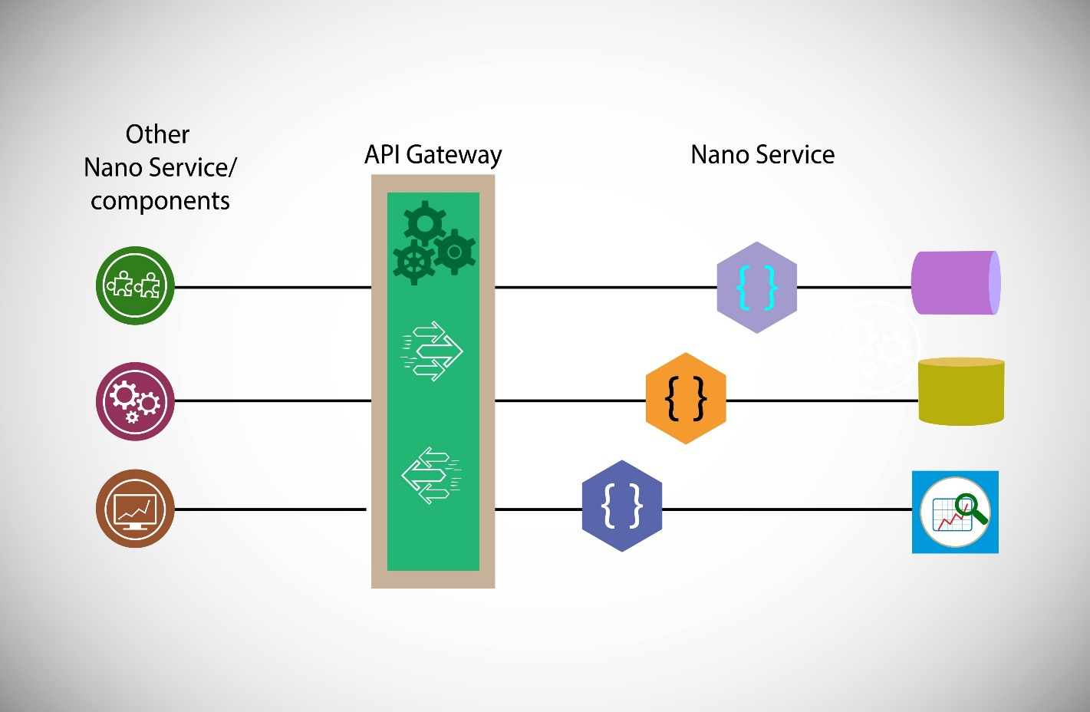
Shutterstock
3. High Availability and Reliability
A system should stay functional even if parts of it fail. This is often achieved through redundancy (having backups of data and servers).
4. Data Partitioning (Sharding)
As databases grow, they become slow. Sharding involves breaking a large database into smaller, faster, more manageable parts called "shards."
5. Caching
To speed up a system, frequently accessed data is stored in a temporary storage area (the cache) so the system doesn't have to fetch it from the main database every time.

The System Design Process
When approaching a design problem, engineers typically follow these steps:
- Requirement Clarification: Defining the goals. Is it a "read-heavy" system (like Twitter) or a "write-heavy" system (like a stock trading app)?
- Estimation: Calculating the expected traffic, storage needs, and bandwidth.
- System Interface Definition: Identifying what APIs the system will provide.
- Database Design: Choosing between SQL (relational) or NoSQL (non-relational) based on how the data needs to be stored and accessed.
- High-Level Design: Drawing the main components (Web Servers, Load Balancers, Databases, Caches).
- Detailed Design: Narrowing down on specific bottlenecks, such as how to handle concurrent users or data consistency.

Why It Matters
System design is what separates a simple app from a global platform. While a junior developer might focus on writing an efficient algorithm, a senior architect focuses on how that algorithm fits into a system that must serve 100 million people without crashing.
Would you like to dive deeper into a specific area, such as the difference between Monolithic vs. Microservices architectures?

Great choice. Moving from a Monolith to Microservices is one of the most significant shifts in modern software architecture. It’s essentially a trade-off between simplicity and scalability.

1. Monolithic Architecture
In a monolith, the entire application—the user interface, the business logic, and the database access—is bundled into a single codebase.
- Pros: Easy to develop, test, and deploy initially. Communication between components is instant because they are in the same memory space.
- Cons: As the app grows, it becomes a "Big Ball of Mud." If you want to update one tiny feature, you have to redeploy the entire system. If one part crashes (e.g., a memory leak in the payment module), the whole site goes down.
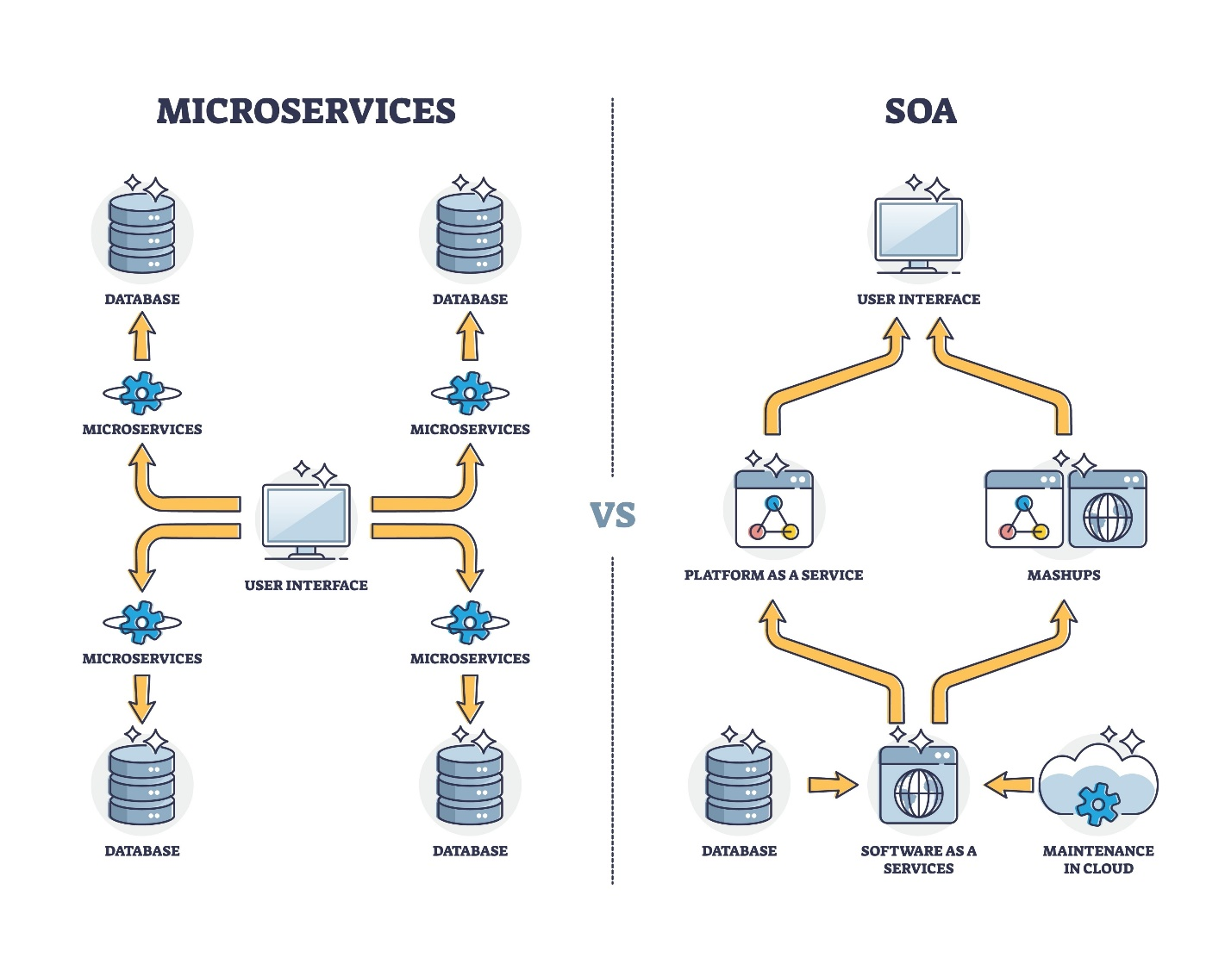
Shutterstock

2. Microservices Architecture
Here, the application is broken down into a collection of small, independent services that communicate over a network (usually via HTTP or message queues). Each service handles one specific business function (e.g., "User Service," "Order Service," "Payment Service").

Key Characteristics:
- Independent Scaling: If your "Search" feature is getting slammed but "Settings" is quiet, you only need to add more servers to the Search service.
- Technology Agnostic: You can write your Payment service in Java and your Data Analytics service in Python.
- Fault Isolation: If the "Recommendation" service crashes, users can still log in and buy products; they just won't see "Recommended for You" items.

Comparison Table
Feature | Monolith | Microservices
Complexity | Low (at the start) | High (requires DevOps & networking)
Deployment | All or nothing | Independent per service
Data | Single shared database | Each service has its own database
Reliability | Single point of failure | Isolated failures
Performance | Faster internal calls | Network latency between services

When to Use Which?
- Choose Monolith if you are a small team building a Minimum Viable Product (MVP). You need speed of development more than massive scale.
- Choose Microservices if you are a large organization with multiple teams. It allows teams to work at different speeds without stepping on each other's toes.
Fun Fact: Most giants (Netflix, Amazon, Uber) started as monoliths and only migrated to microservices once their original codebases became too massive to manage.
Would you like to see a breakdown of how these services actually talk to each other, specifically through APIs or Message Queues?

I have summarized our discussion on System Design and Monolithic vs. Microservices Architecture into the structured guide below. You can copy this content directly into a document (like Word or Google Docs) and select "Save as PDF" to create your file.

System Design & Architecture Overview
Part 1: Fundamentals of System Design
System design is the process of defining the architecture, components, and data for a system to satisfy specific requirements. It acts as the blueprint for how parts interact, scale, and handle failure.
Core Pillars
- Scalability: Handling growth via Vertical Scaling (more power to one machine) or Horizontal Scaling (adding more machines).
- Load Balancing: Distributing incoming traffic across multiple servers to prevent bottlenecks.
- High Availability: Using Redundancy to ensure the system remains functional if a component fails.
- Data Partitioning (Sharding): Breaking large databases into smaller, faster "shards."
- Caching: Storing frequently accessed data in temporary storage for rapid retrieval.

Part 2: Monolithic vs. Microservices
Monolithic Architecture
A single, unified codebase where all functions (UI, business logic, database) are managed together.
- Best for: Small teams, MVPs, and rapid initial development.
- Risk: A single bug can crash the entire application; harder to scale specific features.
Microservices Architecture
An application built as a collection of small, independent services communicating over a network.
- Best for: Large organizations, complex applications, and high-scale environments.
- Benefit: Fault isolation (one service failing doesn't kill the app) and independent scaling of components.
Comparison Summary
Feature | Monolith | Microservices
Complexity | Low (initial) | High (requires DevOps)
Deployment | All-or-nothing | Independent per service
Data Strategy | Single shared database | Per-service databases
Failure Impact | High (Entire system) | Low (Isolated service)

Part 3: Communication Patterns
In a distributed system, services must communicate. This is typically handled via:
- Synchronous (APIs): Direct request-response (e.g., REST, gRPC).
- Asynchronous (Message Queues): Decoupled communication where a service sends a message and continues its work (e.g., RabbitMQ, Kafka).

Would you like me to expand on API Design (REST vs. GraphQL) or Database Selection (SQL vs. NoSQL) to include in your notes?

